It was a clear, bright sunny morning of passing out parade day. A morale boosting day, a mood elevator morning and a dream of every cadet to be material and into reality. The blood circulation of all the cadets passing out get faster and their chest takes a great leap even higher then Himalayans with pride and passion. Smartly turned out cadets marched in with traditional zeal on the tunes of military band. For next 90 minutes or so, the audiences were mesmerized by perfect drill movements of cadets and periodic applause broke gaze of most of them. Attending such parade come as a pleasant surprise for most of people.  However, on that bright morning , there was yet another surprise for many who were occupying enclosure next to cadets of first & second terms who were not part of the parade. It was a young cadet wearing turban with green stripe on both sides instead of beret with uniform usually worn by cadets. |  | 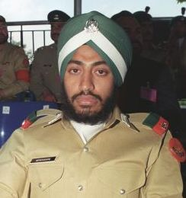
Surely, the young boy was a Sikh cadet and sitting in Pakistan Military Academy Kakul. To the surprise for most of people, he is the first Sikh Gentleman Cadet of Pak Army Harcharan Singh.
He belongs to Nankana Sahib which is the birth place of the founder of Sikh religion Guru Nanak and is situated 280 km south of Islamabad . At present, Harcharan Singh is being trained in the 2nd term of the 116th PMA Long Course.
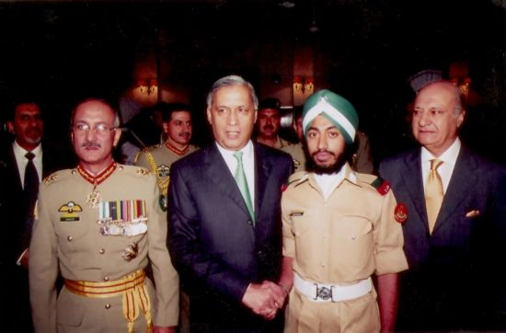
Gentleman Cadet Harcharn Singh with Prime Minister Shaukat Aziz
After meeting the Prime Minister upon his arrival at the academy during the passing out, Harcharan Singh said while talking to the media that he is proud of being a Pakistani and in the Pakistan Army. While expressing his extreme excitement on being a part of this dignified institution, he said that the Sikh youth settled in Pakistan should have joined this institution a long time ago. Regarding his future plan, he said with great zeal that being a Sikh, it is my burning desire to embrace Martyrdom. He told that initially his mother was little reluctant upon his induction in the Pak army as he is her eldest son but now his presence in the Pak Army brings her the greatest honour and pride. He told his fellow cadets once, “It is my great ambition to be a martyr while defending the mother-land”.
Gentleman cadet Harcharan Singh regularly informs his younger brother about his activities in this distinguished institution. He was first admitted in National Arts College but ended up in PMA to fulfill his dream of becoming an officer in the Pak Army.

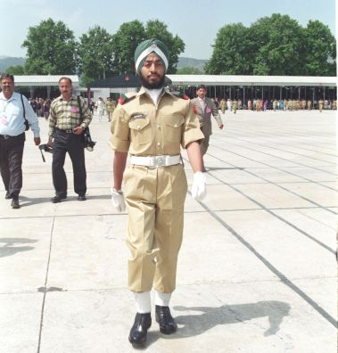
GC Harcharn Singh in the Drill Square of PMA after the passing out parade of a senior course
His instructors and fellow cadets view Harcharan Singh's companionship with appreciation as he is good friend and a nice companion. Many Christian and Parsi officers and Jawans are already serving in Pak Army and Harcharan Singh would be the first Sikh officer to take commission in the Pak Army
First Sikh officer in Pakistan Army

By Zulqernain Tahir
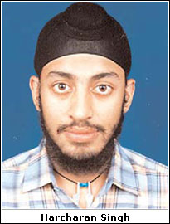
LAHORE, Dec 19: Harcharan Singh, 19, of the Nankana Sahib, is the first Pakistani Sikh in the country’s 58-year history who has been commissioned in the Pakistan Army as an officer.
The minorities in Pakistan are allowed to sit in all examinations, including the one conducted by Inter Services Selection Board (ISSB), but neither a Hindu nor a Sikh could get selected for the army service since the country’s inception. However, many Christians served in the army.
Harcharan was skeptical this year while appearing in the ISSB’s preliminary tests, thinking that such examinations were not meant for them (Sikhs) as he could not get through the initial phase last year.
“This year, I got through the preliminary phase and appeared in the ISSB examination. However, I was mentally prepared to take admission in BA (Architecture) in the National College of Arts”.
“It was the happiest moment of my life when I came to know about my selection in the army. I am privileged to have this honour which none of my predecessors could ever achieve,” Harcharan told Dawn.
Harcharan, who passed his FSc (pre-engineering) in 2004 with 726 marks, wants the government to open the doors for his community to the law enforcing agencies as well.
Harcharan passed his matriculation from the Government Gurunank High School, Nankana Sahib, with 677 marks. He says that his school should be equipped with modern laboratory and competent teaching staff.
He says when his fellow Sikhs in Nankana Sahib learnt about his selection in the army they really felt proud of him. It has also changed their perception. Now they believe that young Sikhs have a fair chance to join the country’s most prestigious institutions.
Having a younger brother and three elder sisters, he wants his brother to follow suit. He says after the death of his father, a shopkeeper, some seven years ago, the credit of their education goes to his mother. “My mother wants me to earn a good name for the country.”
He says that his family migrated to the Northern Areas at the time of partition and in 1970s shifted to Nankana Sahib.
