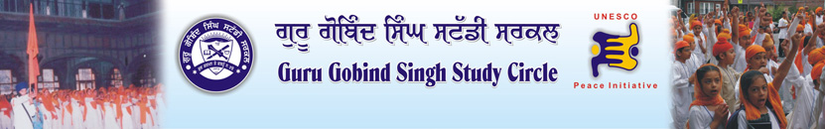

Bottom of Form

About u

  Zones
  » Amritsar
  » Chandigarh
  » Faridkot-Mukatsar-Bathinda
  » Fathegarh Sahib-S.A.S Nagar (Mohali)
  » Firozpur-Moga
  » Head Office
  » Hoshiarpur-Navashehar
  » Jalandhar
  » Ludhiana
  » Ropar
  » Sangroor-Patiala-Mansa
  States
  » Delhi
  » Gujrat
  » Haryana
  » Jammu
  » Jammu and Kashmir
  » Jharkhand
  » Orissa
  » Punjab
  » Rajasthan
  » U.P.
  » West Bengal
  Overseas
  » Canada
  » U.S.A
  » United Kingdom
  Activities >> Current Activities
  <<Previous | Next >>
  Seminar on Seva
  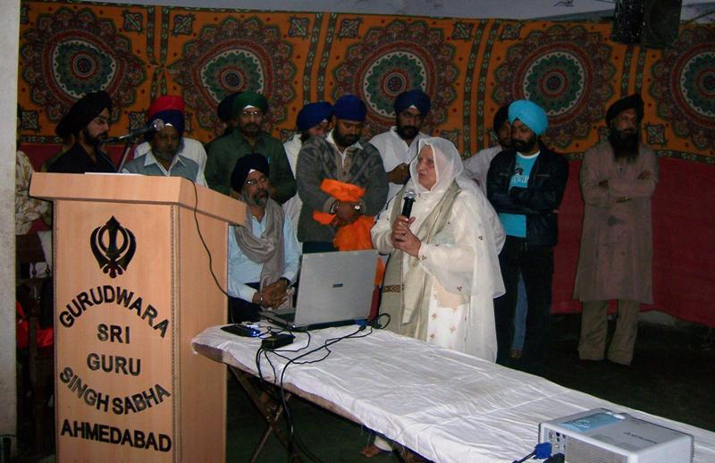
  Guru Gobind Singh Study Circle, Gujrat State organized a convention cum training of social services programme on Saturday the 15th December, 2007 at Gurudwara Sahib, Krishna Nagar, Ahmedabad and on Sunday 16th December, 2007 at Gurudwara Sri Guru Singh Sabha, Dudheshwar, Ahmedabad. Shri Bhupinder Singh Ji from Mumbai shared his personal experiences of his 23 years of his compassionate work in the field of social work with the Sangat. He explicate as to “what, where and how” social activities can be conducted & which was demonstrated through slide shows and documentary films along with the examples of various social projects handled by him for the welfare and wellbeing of the society and for the renounced people. S. Pritam Singh, Sharanbir Singh and Gurdayal Singh (Retd. IAS – DGP of Gujarat) and Gopal Singh Khalsa (Retd. Deputy Commissioner of municipality) gave honour to Bhupinder Singh Ji family by giving them saropa saheb. Satnam Singh, Daljeet Singh, Vishal Singh and all the youth wing of Ahmedabad Unit were also present on this event.

